Guide for Trainers
Enabling independence and connectivity for people with vision impairment (PVI) through learning smartphones
Content
Overview of Toolkit and its Development 2
How to Use This Guide? 3
- Introduction 3
- Training Approaches and Format 5
Training Process 9
- Overview of Training 9
- Assessment 9
- Collaborative Goal Setting 11
- Evaluation of Goals 12
- Content for Training 17
- Explore Your Phone
- Just Basics
- Screen Display Settings
- Screen Readers
- Calling & Messaging
Tips to Support Learning 20
References 24
Glossary of Terms 26
Co-Design Team 26
Funded by | Supported by 28
Need Help? 29
Overview of Toolkit and its Development
This co-designed web-based toolkit https://www.smartphone-trainingforpvi.guidedogs.org.sg with its associated guides for different (PVI, trainers, family and support persons) provides training and learning support on the use of smartphones and apps for people with vision impairment (PVI). It is a basic training guide for trainers (professionals who guide PVI to learn how to use smartphones).
Smartphones have become a core piece of assistive technology (AT) for PVI for daily activities and participation. They can be used as effective and relatively affordable AT by PVI with good training and learning support.
This web-based toolkit has been co-designed and co-produced with PVI. Our team includes researchers and a group of trainers and learners with lived experience of vision impairment from Guide Dogs Singapore https://guidedogs.org.sg/. Over a six-month period (between June 2022 to December 2022), the team used the “Experience-based co-design (EBCD)” [The Point of Care Foundation (POC), n.d.] framework to guide the process of co-designing this web-based toolkit. The framework involves 3 phases as illustrated below.
Phase 1: Setting Up
Meetings with Guide Dogs Singapore (GDS) staff to discuss needs of a toolkit and set up project.
Phase 2: Discovery
Gathered data from trainers and learners on their experiences in providing and receiving training in use of smartphones and apps locally and beyond.
Phase 3: Co-Design
Joint co-design meetings with co-design team recruited from GDS to co-design solutions for the structure, design and content outline of toolkit. The co-designed solutions were then implemented by small co-design team discussions.
End of Project
After refining the prototype developed together, the finishing of the web-based toolkit was presented to stakeholders via a small celebratory event.
How to Use This Guide?
This guide has been co-designed for the trainers who guide PVI to use the smartphones.
To complement this guide, we have created a companion website at https://www.smartphone-trainingforpvi.guidedogs.org.sg. The website offers concise summaries of the guide’s content and allows you to access the mentioned videos for further guidance and support.
You can visit the website or refer to the relevant section of this guide that applies to you and the applicable smartphone platform (i.e. Android/iOS) that has links to the videos for learning.

Introduction
If you have a professional role in supporting PVI to learn smartphones, the resources here provide a range of information to support PVI on learning to use smartphones. This includes how to begin the training process for basic use of smartphones; the recommended training approaches; how to carry out evaluation of the training; and some tips for training.

Previous research [Spafford et al., 2010; Tan et al., 2023 (under review)] has indicated that training fosters hope, independence and connectivity for PVI, which are important but not explicitly presented when learners engage in formal training (e.g., training offered by organisations such as Guide Dogs Singapore) or other forms of training (e.g., learning from other friends with vision impairment). In the following sections, we will present some topics other trainers have considered when they planned their training, including approaches used, and factors that influence training approaches and outcomes. The following sections were informed by a qualitative research we carried out with 22 trainers from Australia, Canada and Singapore, as well as discussions within the co-design research team [Tan et al., 2023 (under review)].
Our qualitative research found that stories and experiences shared by trainers with lived experience of vision impairment was especially valuable in the training process and helped to motivate learners further. Often, trainers shared their lived experience in response to their learners’ emotional needs and readiness for training. This sharing was described by the trainers interviewed, to help their learners overcome some of the frustrations they encountered because of their vision loss or deteriorating vision.
For instance, the trainers in the research commented that when a learner’s vision deteriorates and needs to use VoiceOver to access the phone, he/she may not be emotionally ready to stop relying on his/her residual vision when accessing the phone. Therefore, trainers may need to be aware where their learners are at in relation to the learner’s stage of vision change. Some of the members of our co-design team explained this transition to using VoiceOver to access their smartphones rather than their residual vision, was like they were admitting that “they are going blind” and that they needed time to grieve this loss. A tip shared by the team for trainers who are supporting PVI in this situation is to offer options of learning both the low vision features and screen readers and explain knowing both will enable choices to use different features depending on the situation and environment. For example, in noisy environments, it may be easier to use low vision accessibility features to operate the smartphone whereas when it is difficult to see the screen if one's eyes feel tired/strained, then using screen readers can be more convenient.

Training Approaches and Format
Summary of points to consider for training approaches and format:
- Every learner is unique. Always strive to understand your learner well in order to custom design an individualised and graded training.
- Individual face-to-face training sessions are preferred by both trainers and learners, but group training sessions are also useful and helpful. Group sessions enable networking and socialisation amongst PVI, which is also essential.
- Do plan for post training follow up to continue supporting your learners in their journeys to use smartphones as AT.
Understand Your Learner Well to Design An Individualised And Graded Training
Apart from being mindful of the learners’ readiness to learn during training, trainers also shared that understanding learners’ personal factors is also crucial, as illustrated in the section below. As each individual learner is unique in their skills, experience with technology, learning style and motivation to learn smartphones, trainers should be mindful of these factors during training. Previous research has recommended individualising training programmes to cater to each learner’s unique learning needs and capacities (Robinson et al., 2017; Senjam, 2021; Wong & Tan, 2012). This can be achieved by understanding each learner well - you can refer to our assessment section further down to gain some tips on how to do this. Trainers have also recommended to use a graded approach during training. This means starting with teaching simple skills and allowing learners to experience small successes along the way to keep them motivated throughout learning. Remember, some learners may also have other difficulties, such as joint stiffness, cognitive challenges, or poor memory, that makes learning difficult besides fear of technology or lack of confidence in using technology. Hence patience is key, understanding and encouraging learners as they learn, as mentioned by our team members, is also important. It has also been found that relating learning topics to how learners use the smartphones in daily activities, is helpful during training. As a trainer, you can consider questions such as how will learning smartphones enable participation in the learner’s activities of daily living, navigation, work and leisure.
Formats of Training for Consideration
Another point to consider is the format of training. Trainers in our research, as well as the trainers and learners in our team shared their thoughts about training format. Although individual one-to-one, and face to face training are preferred by most trainers and learners, there are merits to group training too. The advantages of group training include that PVI can be connected to other PVI and sometimes when they see that others are experiencing similar issues, it can reduce their anxiety about learning. Learners can also form a buddy system to check in with each other post training, to form an informal support network and share tips about smartphone technology or form friendships.

For some organisations with a long waiting list for new learners who need support to learn basic skills, some trainers suggested that group training works well to allow quicker access to learn to use smartphones, where PVI can learn basic skills in smartphone use as a group first, then receive individualised support on more advanced skills and tailored learning to their needs. This format works well, as individual one-to-one sessions following group learning in basic skills means users will know which topics they would like to focus on, after learning the basic skills to operate the smartphone.
Other suggestions from the research and co-design team included holding workshops for group sessions to cater to larger group of learners with similar skills or interest in certain topics. While group training offers benefits, there are some disadvantages to group training as well. This includes it can be difficult for one trainer to cater to a group of learners simultaneously as everyone’s learning speed, aptitude and goals are different. To overcome this, it is advisable to have more than one trainer facilitating group sessions, and even consider getting a sighted assistant if the trainer has vision impairment. Sighted assistants can help to troubleshoot faster, for e.g. whether learners are doing the finger gestures wrongly by looking at how learners are doing them. During group sessions, it can also be noisy and disruptive if everyone is using screen readers at the same time.
Online Learning
Online learning is here to stay since the pandemic and some learners prefer to have a hybrid mode of learning. That means, having access to online learning as well as face to face learning. Online learning can also cater to those who have difficulties travelling to a fixed venue to learn. However, during remote learning, it is important to ensure that learners know how to set up to use the Zoom platform and that there is stable Wi-Fi for both trainers and learners to not disrupt the flow of teaching and learning. During online learning, sighted family members or support person can also be available to ensure that the PVI learns the gestures appropriately. By also learning the use of smartphone’s accessibility features, the family member/support person can also revise with the PVI after the learning session has ended.
Duration of Training
Lastly, do consider the duration of training for each learner. Generally, most learners and trainers have found a minimum of 60 minutes of learning session is necessary to teach some skills, as well as to cater to the concentration span of most learners. Some would prefer 90 minutes and even longer, depending on the concentration span of the learner.
Essential Post Training Follow-Up Support
Our research [Tan et al., 2023 (under review)], as well as other research, have found that post training follow-up is important to consolidate learning (Fuglerud et al., 2021). This can be carried out in different forms. For example, having training notes available for learners to review materials and content covered during the session would help. The notes can be in print form in large font; emailed to learners; or the session can be audio recorded. Some trainers in our research reported that they would ask learners to practise what has been learnt before the next learning session or use the subsequent session to revise what has been taught previously to consolidate previously learnt content. Another way is to check in if learners encountered any difficulties after the learning session with what was taught. Having drop in clinics is another way of following up with learners after formal training sessions have ended. Some trainers have a system of assigning a volunteer (sighted or non-sighted) to the learner for a few sessions post training, to encourage continual learning.
Training Process

Overview of Training
- Assessment
- Collaborative Goal Setting
- Individualised And Graded Training
- Evaluation of Goals at the End of Training
- Post Training Follow-Up Support

Assessment
It is important to understand learners’ needs and skill levels prior to training. We term this phase of training as the “assessment” phase. During this phase, asking learners informative questions is an important step so we can design the learning plan collaboratively with learners.
Below are some suggested assessment questions which you can use to find out more about your learner to tailor an individualised learning session plan:
- Have you had any experience in using smartphones? If no, “how do you feel about using a smartphone?” What are your concerns, if any, or if there’s anything that’s worrying you with regards to using smartphones? (some probing questions to give trainer an idea on their hesitation about accessing training)
- Do you have experience with other forms of technology, e.g. other ICT or Assistive technology?
๏ If yes, which platform (Android or iOS) have you been using?
- What model of phone are you using now?
- How long have you been using the smartphone and what accessibility features are you currently using?
- What activities would you like to use the smartphone for? For e.g., for navigation, for reading e-books, for listening to music, for work purposes etc?
- What prompted you to want to learn more about accessibility features for PVI on the smartphone?
- Can you show me some of the accessibility features which you are using on your smartphone now?
- Do you think there are obstacles to your learning to use the smartphones now? If yes, please tell me more.
- For those obstacles that you mention, what is your level of confidence of overcoming them so that learning can occur?
- If you think you can’t overcome those obstacles, would you be fine with not learning to use the smartphone’s low vision accessibility features now?
During this initial session of finding out more about the learner, trainers may wish to also gauge learner’s readiness to learn a new skill, as some of them, as mentioned before, may not be ready to make a transition. It is important to give learners time to share their frustrations and support them when appropriate. However, it may be helpful to refer some of them to professional services if you are not sure how best to support them or if their issues are ongoing. For instance, in Guide Dogs Singapore, we work with other social service agencies which can provide counselling to learners if need be. Do consult your local area’s professional counselling service providers to make an appropriate referral. It is also recommended that trainers get more training in handling such delicate situations too.
Apart from encountering learners who are not ready to learn, some trainers have also come across learners who do not know what they would like to learn about smartphone use. This can happen because the learner may not have used a smartphone before or is exploring which smartphone to purchase. At times like this, trainers can share with them how other PVI use their smartphones to give learners ideas of how smartphones enable independence for PVI in work, daily activities and leisure. Once the learner has some ideas about what they could use their smartphone for and if they want to learn, trainers can work on goal setting with them.

Collaborative Goal Setting
It is important that trainers set goals for learning with their learners rather than for them. Literature has supported when collaborative goal setting is carried out involving learners (in our context), it can increase motivation and satisfaction as well as instill a greater sense of ownership in learners (Page et al., 2015; Turner-Stokes et al., 2009). Collaboratively set goals will encourage commitment from the learners as these goals reflect their needs and wants (Holliday et al., 2005). One way to collaboratively develop goals that can guide the progress of the learners is to use SMART goal format. SMART goals refer to goals which are Specific, Measurable, and/or Realistic and has a Time frame for achieving it (Page et al., 2015).
There can be an overarching SMART goal for the overall learning, and individual session goal/s to signpost the teaching and learning. For example, the goal below is for a learner who was an avid reader before their vision loss and wants to get back to reading again, but now instead of using a magnifier app to enlarge the print, they want to use screen readers, such as VoiceOver or TalkBack, to access e-books from an app. The overarching SMART goal for this person would be for:
To use a screen reader to access an e-book in the Libby app by the end of 10 sessions.
Session goals could then be structured around this overarching goal. Below are examples of session goals to reach the overarching goal. Each training session can contain a session goal or a few session goals, depending on the learner:
a. To learn how to turn on/off screen reader in smartphones
b. To learn how to use basic gestures to use screen reader
c. To select a "voice" for the screen reader
d. Learning more advanced hand gestures for web browsing purposes
e. To learn how to download Libby app
f. To learn how to search for a book using screen reader
g. To learn how to borrow a book in the app and start reading it using the screen reader

Evaluation of Goals
Goals can also be evaluated more formally using standardised evaluation tools, for example, the "goal attainment scale" (GAS) (Roberts & Aberty, 2023). GAS is often used in rehabilitation settings to objectively measure the goals attained and change in a person.
While GAS is a useful outcome measure, it can be too rigorous and time-consuming. Therefore, another simplified way to approach this is the use of the "GAS – light" model (King’s College London, n.d.).
As recommended by Turner-Stokes et al. 2009, using the GAS-Light approach to goal evaluation involves six steps:
- Set one to six key SMART goals collaboratively. The SMART goals will describe "the expected level of achievement" (p. 211).
- For each key SMART goals, short-term staged goals that work towards achieving the key SMART goal can be identified and evaluated throughout. This enables the tracking of progress and can serve to adjust the timeframe to achieve the key SMART goal if necessary.
- At the review session with your clients, "rating of goal attainment against the key SMART goals" can then be undertaken (p. 211).
- To rate the attainment of the key SMART goals, a six-point verbal scale is used and will be converted to a five-point numerical scale (-2, -1, 0, +1, +2) (Kiresuk and Sherman, 1968). The overall score (i.e., GAS T-score) can be calculated using the five-point scale. It can then be used to assess your learner's progress by also incorporating the level of importance and difficulty assigned by the learner for each key SMART goal. You can calculate GAS T-score using the Excel worksheet from King’s College London website (King’s College London, n.d.).

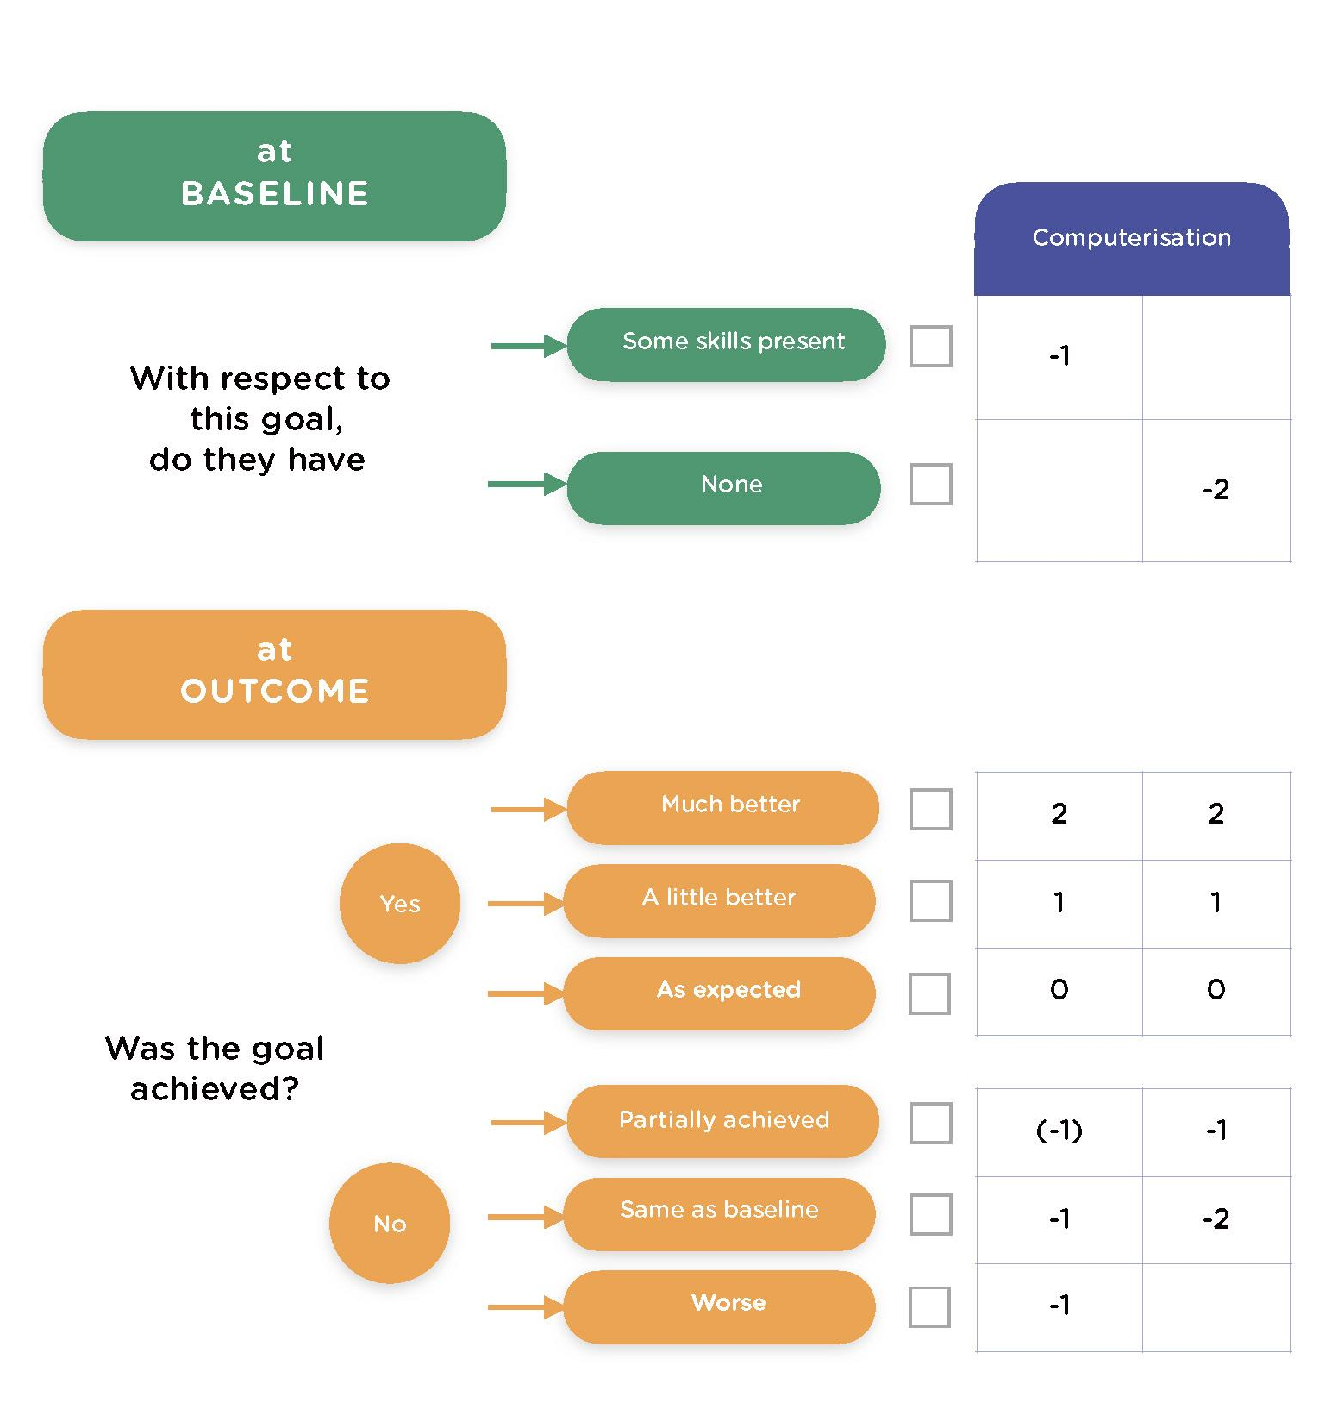
Figure to show conversion of six-point verbal scale to a five-point numerical scale.
To illustrate the calculations explained above, a case example has been developed for reference, with the score sheet form adapted to suit the smartphone learning context.
Goal Attainment Scaling (GAS-LIGHT) Record Sheet
Client’s Name: Mark
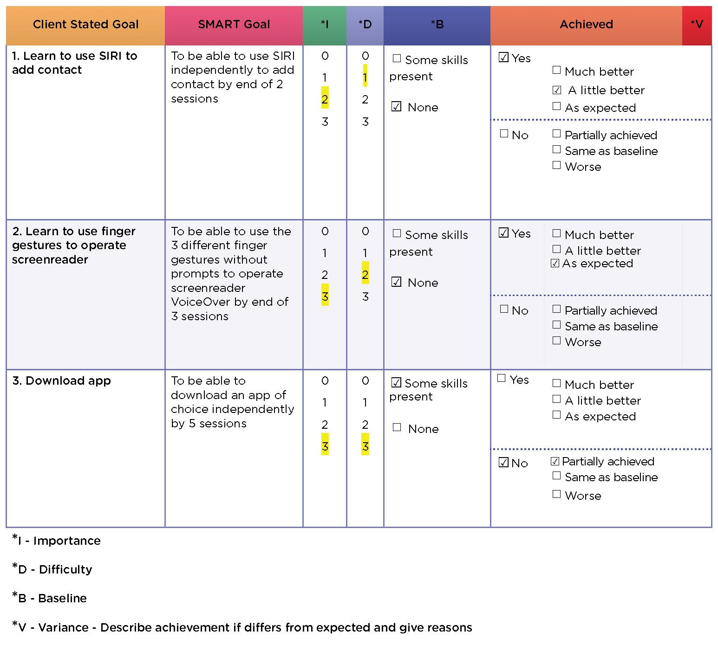
Date of Review: March 2023

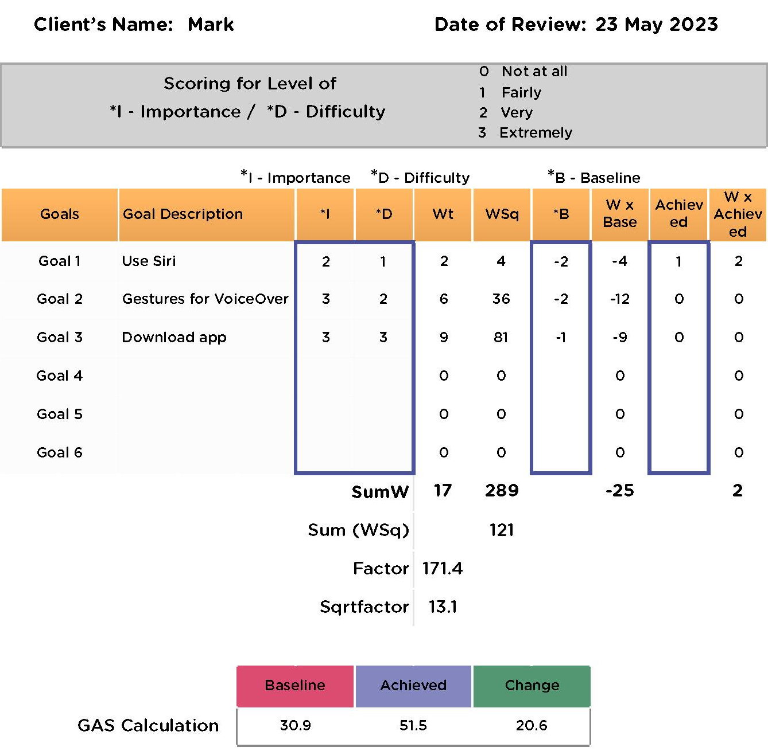
To tabulate the scores, in the excel file with pre-set calculation formulas (accessible via the link provided in next ), the above scores have been keyed into the excel worksheet:

As viewed from above, there is a positive change (an increase of 20.6 from baseline) in the overall score/GAS T-score, and that shows improvements after the learning sessions.
To learn the use of GAS and GAS-Light well, you may refer to the resource page by Kings College London https://www.kcl.ac.uk/cicelysaunders/resources#GAS
Content for Training
During our experience-based co-design process to develop this training web-based toolkit, the team discussed and agreed on what are the essential basic skills to learn PVI to learn for the smartphone’s accessibility features. Based on these discussions with the team, we have laid down the essential foundational skills. These foundational skills are the same across the 2 platforms (Android and iOS) and include:
- Explore Your Phone
- Just Basics
- Screen Display Settings
- Screen Readers
- Calling And Messaging
- Contact
- Calling
- Messaging

Explore Your Phone
This video explains how you touch around your phone and get to know the physical basic parts of your phone.
- Exploring Your Android Device
If you are using an Android smartphone, click this link https://www.youtube.com/watch?v=qv1hnIuR0cc&t=2s to watch the video on Explore Your Android Device.
- Exploring Your iPhone
If you are using iPhone, click this link https://www.youtube.com/watch?v=2h4aIPjglzk to watch the video on Explore Your iPhone.

Just Basics
This video explains how to power on/off your phone, how to bring up virtual assistance (i.e. Siri/ Google assistant), and how to adjust the volume.
• Just Basics for Android Devices
If you are using an Android smartphone, click this link https://www.youtube.com/watch?v=m8uY-_Wnirw to watch the video on Just Basics for Android Devices.
• Just Basics for iOS Devices
If you are using iPhone, click this link https://www.youtube.com/watch?v=EJ8P8g4IGlE to watch the video on Just Basics for iOS Devices.

Screen Display Settings
This video explains how you can customise your screen display settings to suit your needs and make it easier to see. This is mainly applicable to people with low vision who uses their residual vision to see the screen.
• Screen Display Settings for Android Devices
If you are using an Android smartphone, click this link https://www.youtube.com/watch?v=mnTFE74Whdw to watch the video on Screen Display Settings for Android Devices.
• Screen Display Settings for iOS Devices
If you are using iPhone, click this link https://www.youtube.com/watch?v=JRz4LoQOr6I to watch the video on Screen Display Settings for iOS Devices.

Screen Readers
Screen Readers - VoiceOver on Apple iOS and TalkBack on Android devices give you audible descriptions of what’s on your screen.
• Basic Gestures for Android Devices with TalkBack
If you are using an Android smartphone, click this link https://www.youtube.com/watch?v=QxB5GYoVvuc to watch the video on Basic Gestures for Android Devices with TalkBack.
• Basic Gestures for iPhone with VoiceOver
If you are using iPhone, click this link https://www.youtube.com/watch?v=qNTHJRe5yV4 to watch the video on Basic Gestures for iPhone with VoiceOver.

Calling And Messaging
Basic Communications – This video series explains
- how to add contacts,
- make and receive phone calls,
- and how to send and receive messages.
This involves using the built in contact list, message and phone apps in all smartphones.
The team recognises that WhatsApp app and Telegram app are also other useful platforms for calling and messaging, however these apps are considered by the team as being more advanced level apps for users, and that you need to know how to search and download these apps in the app stores of either platform before you can use them. Hence, these skills will be covered in future versions of the web-based toolkit which aim to support the learning of more advanced skills.
For Android
If you are using Android smartphones, click the links to watch the videos on 3 topics under Calling & Messaging:
• Adding Contact and Sending Text Messages Using the Contact List https://www.youtube.com/watch?v=FeDM68Hvux0
• Make and Receive Phone Calls
https://www.youtube.com/watch?v=uL5OlxY9_KM
• Sending and Receiving Messages
https://www.youtube.com/watch?v=H3-E73liEok
For iPhone
If you are using iPhone, click the links to watch the videos on 3 topics under Calling & Messaging:
- Adding Contact and Calling Using the Contact List
https://www.youtube.com/watch?v=t08NQA-IV3U&t=1s
- Make and Receive Phone Calls
https://www.youtube.com/watch?v=xmoQ1fMyXGo
- Sending and Receiving Messages
https://www.youtube.com/watch?v=aNYuufxt0co
Tips to Support Learning
The following tips to support learning have been collated from sources including our own co-design process as well as our previous research which interviewed 22 trainers from Australia, Canada and Singapore [Tan et al., 2023 (under review)]. Since smartphone technologies advance quickly, trainers have said that it is important to stay curious and keep learning what is new out there.
- If you are a sighted trainer – it is important to be competent in teaching PVI the accessibility features on their smartphones, the best way is to learn this is to use the smartphone like a blind person. This means you may want to blindfold yourself and use your smartphone without vision, this will allow you to have some perspective of using a smartphone with little or no vision and to become proficient in these skills with more practice.
- For sighted trainers, it is important to be mindful to be descriptive of your actions you are taking when you teach rather than of visual information. Saying tap on the “yellow” icon or “this button” is not helpful to a non-sighted person. Instead, say there is an icon which is in the bottom left corner which you need to tap on, or the apps are lined up in the home screen like little squares.
- Avoid the use of jargon and use simple terms. Or if you have to use jargon, make it a point to explain what these terms mean to learners. We have compiled a list of terminologies https://www.smartphone-trainingforpvi.guidedogs.org.sg/useful-resources/Basic%20Terminologies.docx that will help explain the common jargon associated with smartphone technology.
- Link learners’ current and prior experience with technology when teaching to let them build on their existing skills. For example, if they know how to use some apps, they can move on to learning how to use more complex apps, such as banking apps to perform banking functions. Or if they have some experience with using other technologies e.g., screen readers on computers, that skill can be transferred to their smartphone learning.
- Smartphone technology advances at lightning speed hence it is important to keep abreast of recent developments in smartphone technologies. Trainers shared with us that they do to keep up to date:
  - Subscribe to technology updates or technology reader websites, such as AppleVis https://www.applevis.com/
  - Join a list serve on smartphone use for PVI to keep posted on what’s out there
  - Challenge yourself to learn a new platform if you are used to one platform only to cater to different learners’ needs.
- Some learners have other challenges besides vision impairment and it is important that trainers are aware of the difficulties these other challenges bring. For instance, finger gestures can be difficult for people with stiff arthritic fingers to perform finger gestures successfully. In such cases, it may be necessary to brainstorm in collaboration with the user on how they can operate the smartphone without using gestures. Another example of varied learning needs is when a person’s memory is limited, it can make recalling what has been taught difficult. This requires more patience from both trainer and learner to repeat what has been taught and learn a few times in order for mastery to take place.
- Not everyone likes the sound of “homework” but practice after learning helps to consolidate learning. Trainers shared that instead of stipulating homework, they try to incorporate learning into the person’s everyday life. For example if they would ask the learner to save a contact and call/text the person whose contact has been saved to practice the skills of saving a contact and calling using the phone app. Or if other navigation apps have been taught, the trainer and learner can arrange to meet at a new place for the next learning session in order for the learner to apply the skills taught in the navigation app.
- Teaching hand/finger gestures such as “swipe”, “tap” were reported to be difficult for some trainers. Some tips to do this included using “hand over hand” guidance (with permission, of course!), or the learner demonstrating the gestures on the trainers’ palm to execute the right pressure for “tap”. Alternatively, you can describe the “swipe” gesture such as flicking some small stuff off a surface.
References
Fuglerud, K. S., Tunold, S., & Kjæret, K. (2021). Social Contact for Older People with Visual Impairment Through Mastery of Smartphones: Barriers and Suggested Solutions. Studies in health technology and informatics, 282, 415–428. https://doi.org/10.3233/SHTI210417
Holliday, R. C., Antoun, M., & Playford, E. D. (2005). A survey of goal-setting methods used in rehabilitation. Neurorehabilitation and neural repair, 19 (3), 227–231. https://doi.org/10.1177/1545968305279206
King’s College London. (n.d.). Cicely Saunders Institute of Palliative Care, Policy & Rehabilitation. https://www.kcl.ac.uk/cicelysaunders/resources#GAS
Kiresuk, T. J., & Sherman, R. E. (1968). Goal attainment scaling: A general method for evaluating comprehensive community mental health programs. Community mental health journal, 4 (6), 443–453. https://doi.org/10.1007/BF01530764
Page, J., Roos, K., Bänziger, A., Margot-Cattin, I., Agustoni, S., Rossini, E., Meichtry, A., & Meyer, S. (2015). Formulating goals in occupational therapy: State of the art in Switzerland. Scandinavian journal of occupational therapy, 22(6), 403–415. https://doi.org/10.3109/11038128.2015.1049548
Roberts, M. A., & Abery, B. H. (2023). A person-centered approach to home and community-based services outcome measurement. Frontiers in rehabilitation sciences, 4, 1056530. https://doi.org/10.3389/fresc.2023.1056530
Robinson, J. L., Braimah Avery, V., Chun, R., Pusateri, G., & Jay, W. M. (2017). Usage of Accessibility Options for the iPhone and iPad in a Visually Impaired Population. Seminars in ophthalmology, 32 (2), 163–171. https://doi.org/10.3109/08820538.2015.1045151
Senjam, S.S. (2021). Smartphones as assistive technology for visual impairment. Eye (London, England), 35 (8), 2078–2080. https://doi.org/10.1038/s41433-021-01499-w
Spafford, M. M., Laliberte Rudman, D., Leipert, B. D., Klinger, L., & Huot, S. (2010). When Self-Presentation Trumps Access: Why Older Adults With Low Vision Go Without Low-Vision Services. Journal of Applied Gerontology, 29 (5), 579–602. https://doi.org/10.1177/0733464809345494
Tan, H. L., Aplin, T., & Gullo, H. & McAuliffe, T. (2023). Training and learning support to use smartphones and apps for People with vision impairment (PVI): A multi-site qualitative study on trainers’ perspectives from Australia, Canada, and Singapore (Manuscript submitted for publication). Health and Social Science, Singapore Institute for Technology.
The Point of Care Foundation. (n.d.). EBCD: Experience-based co-design toolkit. https://www.pointofcarefoundation.org.uk/resource/experience-based-co-design-ebcd-toolkit/step-by-step-guide/1-experience-based-co-design/
Turner-Stokes, L., Williams, H., & Johnson, J. (2009). Goal attainment scaling: does it provide added value as a person-centred measure for evaluation of outcome in neurorehabilitation following acquired brain injury?. Journal of rehabilitation medicine, 41 (7), 528–535. https://doi.org/10.2340/16501977-0383
Wong, M. E., & Tan, S. S. K. (2012). Teaching the Benefits of Smart Phone Technology to Blind Consumers: Exploring the Potential of the iPhone. Journal of Visual Impairment & Blindness, 106 (10), 646–650. https://doi.org/10.1177/0145482X1210601008

Glossary of Terms
GDS – Guide Dogs Singapore PVI – Person/People with Vision Impairment
EBCD – Experience-Based Co-Design AT – Assistive Technology
Apps – Applications
POC – The Point of Care Foundation, UK
Co-Design Team
PROJECT LEAD
Designed and led the project
Ms Tan Hwei Lan
Singapore Institute of Technology
The University of Queensland
GUIDE DOGS SINGAPORE
The following team members shared their lived experience of learning and using the smartphone and apps generously during the project team meetings and contributed greatly to the direction of the toolkit and the construction of it throughout, including content writing/editing and script writing and filming of videos in the toolkit:
Mr Au Yew Zhang Dallon
Mr Chia Hong Sen
Ms Amanda Chong
Ms Nurul Natasya Binte Idru
Ms Sherriza Hareani Bte Jalil
Ms Ser Geok Yin (Vivian)
Ms Tan Xing En
Ms Yong Pei Yueng
SINGAPORE INSTITUTE OF TECHNOLOGY
Provided administrative and editing support, and contributed to content writing and editing, filming of videos and post production work on all videos in the web-based toolkit:
Ms Jacqueline Siow
THE UNIVERSITY OF QUEENSLAND
Provided project consultation and helped with editing of content:
Dr Tammy Aplin
Dr Hannah Gullo
Dr Tomomi McAuliﬀe
ACKNOWLEDGEMENT
The team would like to acknowledge
Mr Chew Kuan Hock
(Singapore Institute of Technology – CO-LEAD)
for his generous help with all the videos’ production and editing.


Group Photo of the Co-Design Team:
Front row, from left to right: Amanda, Sherriza, Vivian, Dallon;
Back row, from left to right: Nurul, Jacqueline (Research Assistant), Yong, Hong Sen
Absent from the picture: Xing En
Funded by
Digital For Life Fund https://www.digitalforlife.gov.sg/
Infocomm Media Development Authority https://www.imda.gov.sg/
Supported by
Guide Dogs Singapore https://guidedogs.org.sg/
Singapore Institute of Technology https://www.singaporetech.edu.sg/
The University of Queensland https://www.uq.edu.au/
Need Help?
We are here to support you! If you have any questions or you need more information, please email us at it@guidedogs.org.sg or call us at (+65) 6339 7900.

