Guide for Family and Support Persons
Enabling independence and connectivity for people with vision impairment (PVI) through learning smartphones

Content
Overview of Toolkit and its Development 2
How to Use this Guide? 3
Introduction 3
A Gift of Independence 4
- A Personal Testimonial by Sherizza
The Power of Smartphones as Assistive Technology for PVI 6
Ways You can Support PVI Learning 7
Essential Skill to Learn 8
- Screen Readers
Glossary of Terms 9
Co-Design Team 9
Funded by | Supported by 11
Need Help? 12
Overview of Toolkit and its Development
This co-designed web-based toolkit https://www.smartphone-trainingforpvi.guidedogs.org.sg/ with its associated guides for different (PVI, trainers, family and support persons) provides training and learning support on the use of smartphones and apps for people with vision impairment (PVI). This is a basic training guide for family/support person (including friends and caregivers).
Smartphones have become a core piece of assistive technology (AT) for PVI for daily activities and participation. They can be used as effective and relatively affordable AT by PVI with good training and learning support.
This web-based toolkit has been co-designed and co-produced with PVI. Our team includes researchers and a group of trainers and learners with lived experience of vision impairment from Guide Dogs Singapore https://guidedogs.org.sg/. Over a six-month period (between June 2022 to December 2022), the team used the “Experience-based co-design (EBCD)” [The Point of Care Foundation (POC), n.d.] framework to guide the process of co-designing this web-based toolkit. The framework involves 3 phases as illustrated below.

Phase 1: Setting Up
Meetings with Guide Dogs Singapore (GDS) staff to discuss needs of a toolkit and set up project.

Phase 2: Discovery
Gathered data from trainers and learners on their experiences in providing and receiving training in use of smartphones and apps locally and beyond.

Phase 3: Co-Design
Joint co-design meetings with co-design team recruited from GDS to co-design solutions for the structure, design and content outline of toolkit. The co-designed solutions were then implemented by small co-design team discussions.

End of Project
After refining the prototype developed together, the finishing of the web-based toolkit was presented to stakeholders via a small celebratory event.
How to Use This Guide?
This guide is tailored for family members and support persons seeking to enhance their understanding of how smartphones can facilitate independence for individuals with vision impairment. It provides valuable insights and practical information.
To complement this guide we have created a companion website at https://www.smartphone-trainingforpvi.guidedogs.org.sg/. The website offers concise summaries of the guide's content and allows you to access the mentioned videos for further guidance and support.
You can visit the website or refer to the relevant section of this guide that applies to you and the applicable smartphone platform (i.e. Android/iOS) that has links to the videos for learning.
Introduction
Family members and support persons play a critical role in supporting persons with vision impairment (PVI) in their learning journey to use smartphones. By understanding how smartphones can enable independence and participation for PVI, you can help encourage your family member or friend to learn and overcome any fears or lack of confidence in technology.
A Gift of Independence

Empowering Your Loved One with Visual Impairment:

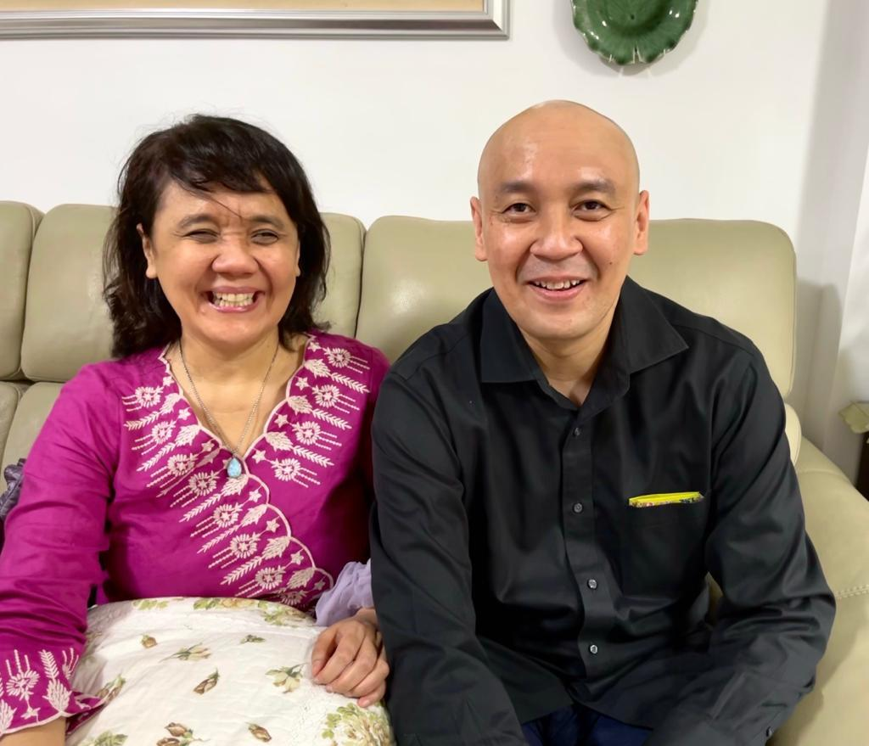
A Personal Testimonial by Sherriza

Photo of Sherriza Jalil with her brother, Danny Jalil
A smartphone, be it iPhone or Android, is something most people with vision impairment (PVI) can’t do without these days. Why? Because the screen reader on a smartphone allows us to use many of the apps sighted people can use, and so, it gives us a higher level of independence.
But I admit, learning to use the smartphone, especially for a person with visual impairment who has never used a smartphone before, can be daunting and demoralising. I speak from experience because I was, in 2010, a person with visual impairment who cried when I learned to use the Voiceover screen reader on my iPhone 3GS. It was the first smartphone with a built-in screen reader. (Android's Talkback screen reader was introduced a few years later.)
When you see your loved one with visual impairment floundering with their smartphone, that’s the perfect time for you, as their caregiver, to swoop in and help, just like my brother did for me.
“ Your family member or friend with a vision impairment will also be grateful to you when you help them learn to use a smartphone, and give them the ability to be more independent.”

Why was it so diﬃcult?
I wasn't used to a touchscreen phone. The design was so exciting, but my excitement cooled when I had trouble mastering the unfamiliar gestures.
Those gestures had alien terms like one-finger/ two-finger/three-finger double tap/triple tap, one-finger/two-finger/three-finger double/triple tap and hold, and one-finger/two-finger/three- finger swipe left/right/up/down.
I struggled. Oh, how I struggled. Until my brother realised my frustration, so he took a little time to learn how to use Voiceover. And because he’s sighted, he could see how each gesture performed a diﬀerent action. The gestures for people with visual impairment are diﬀerent from the gestures a sighted person uses, but they are not hard for a sighted person to learn.
After that, he demonstrated to me how to execute each gesture and for what desired action. Of course, I had to do my part and learn with an open mind. And I had to practice, practice, practice. And very soon, the gestures became second nature to me.
Today, I'm forever grateful to my brother. And I promise you, your family member or friend with visual impairment will also be grateful to you when you give them the gift of independence.
The Power of Smartphones as Assistive Technology for PVI
In recent years, smartphones have become an increasingly popular and aﬀordable assistive technology device for people with visual impairments (PVI). This is largely due to the range of in-built accessibility features and useful native or third-party apps that are available.
Smartphones can be a powerful assistive technology device for PVI when in-built accessibility features are turned on, and useful native or third-party apps are installed.
Some of the most common accessibility features on smartphones include screen readers (see page 8), which can read out the text on the screen, and magnifiers, which can enlarge text and images. These features can be incredibly useful for PVI to navigate and interact with their device.
Moreover, there are also a variety of third-party apps https://www.smartphone-trainingforpvi.guidedogs.org.sg/person-with-vision-impairment.html#apps available that can cater to the specific needs of PVI. For instance, there are apps that can identify objects, read barcodes, and even recognise faces. These apps can enable PVI to accomplish tasks that would otherwise be diﬃcult or impossible without assistance. You can download the list of useful apps for PVIs https://www.smartphone-trainingforpvi.guidedogs.org.sg/person-with-vision-impairment.html#apps which our research team has collated.
By turning on these accessibility features and installing useful apps, smartphones can enable PVI have increased independence and participation. They can help PVI to communicate with others, access information, and perform daily tasks, all without having to rely on others for assistance.
Ways You Can Support PVI Learning
As a family member or support person, you can play a significant role in supporting PVI learning to use smartphones effectively. Learn about ways to encourage and support their learning journey, such as taking up training sessions together, revising what has been taught, and practicing the skills learned in formal training.
One of the most significant ways that you, as a family member or friend can support PVI learners is by learning how to use smartphones' accessibility features yourself. By doing so, you can provide technical assistance to the learner during the learning process, which can help to consolidate the learner's understanding of the features and how they work.
Family members can also assist in ensuring that the PVI has access to stable Wi-Fi during online learning sessions. This can help to prevent disruptions during the learning process, ensuring that the learner is able to remain focused and engaged during the session.
Moreover, family members can also play a role in helping the learner to practice and apply the skills they have learned during the training sessions. For example, they can help the learner to practice using the phone app to call or text someone or practice using navigation apps to find their way around new places. This not only reinforces the skills that have been learned but also helps the learner to become more confident in using their smartphone.
In summary, family support is essential for a PVI learning how to use a smartphone. By providing technical assistance, ensuring access to stable Wi-Fi, and assisting with practice and application of skills learned, family members can greatly enhance the learning experience and contribute to the success of the PVI learner.
Essential Skill for Family Members/Support Persons to Learn
If you are unable to learn most of the skills needed to operate a smartphone, our team members suggest one essential skill that you can consider learning - how to turn on and oﬀ the screen reader feature on the smartphone.
Learning how to turn on and oﬀ the smartphone screen reader feature is an essential skill for emergency situations because it allows family members or support persons to navigate and operate the smartphone on behalf of PVI when necessary.
This video tutorial on the screen reader feature will guide you through the process and explain the importance of this skill in emergency situations. Please refer to the video links below.

Screen Readers
Screen Readers - VoiceOver on Apple iOS and TalkBack on Android devices give you audible descriptions of what’s on your screen.
Basic Gestures for Android Devices with TalkBack
If you are using an Android smartphone, click this link https://www.youtube.com/watch?v=QxB5GYoVvuc to watch the YouTube video on Basic Gestures for Android Devices with TalkBack.
Basic Gestures for iPhone with VoiceOver
If you are using iPhone, click this link https://www.youtube.com/watch?v=qNTHJRe5yV4 to watch the video on Basic Gestures for iPhone with VoiceOver.
Glossary of Terms
GDS – Guide Dogs Singapore PVI – Person/People with Vision Impairment
EBCD – Experience-Based Co-Design AT – Assistive Technology
Apps – Applications
POC – The Point of Care Foundation, UK
Co-Design Team

PROJECT LEAD
Designed and led the project
Ms Tan Hwei Lan
Singapore Institute of Technology
The University of Queensland

GUIDE DOGS SINGAPORE
The following team members shared their lived experience of learning and using the smartphone and apps generously during the project team meetings and contributed greatly to the direction of the toolkit and the construction of it throughout, including content writing/editing and script writing and filming of videos in the toolkit:
Mr Au Yew Zhang Dallon
Mr Chia Hong Sen
Ms Amanda Chong
Ms Nurul Natasya Binte Idru
Ms Sherriza Hareani Bte Jalil
Ms Ser Geok Yin (Vivian)
Ms Tan Xing En
Ms Yong Pei Yueng

SINGAPORE INSTITUTE OF TECHNOLOGY
Provided administrative and editing support, and contributed to content writing and editing, filming of videos and post production work on all videos in the web-based toolkit:
Ms Jacqueline Siow

THE UNIVERSITY OF QUEENSLAND
Provided project consultation and helped with editing of content:
Dr Tammy Aplin
Dr Hannah Gullo
Dr Tomomi McAuliﬀe

ACKNOWLEDGEMENT
The team would like to acknowledge
Mr Chew Kuan Hock
(Singapore Institute of Technology – CO-LEAD)
for his generous help with all the videos’ production and editing.

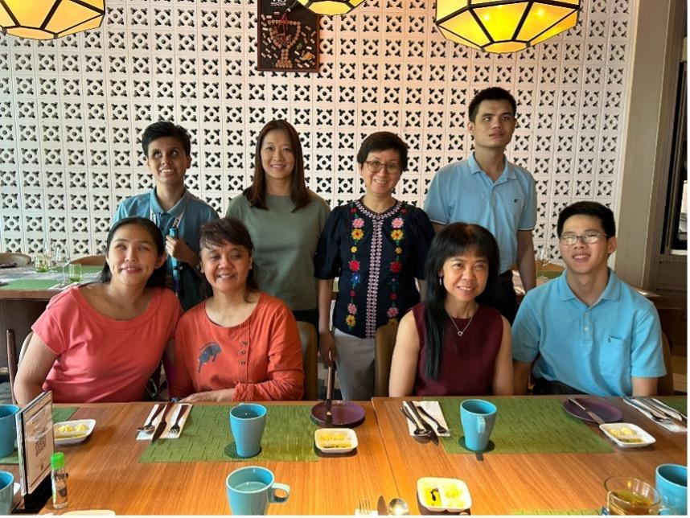
Group Photo of the Co-Design Team:
Front row, from left to right: Amanda, Sherriza, Vivian, Dallon;
Back row, from left to right: Nurul, Jacqueline [Research Assistant], Yong, Hong Sen
Absent from the picture: Xing En
Funded by
Digital For Life Fund https://www.digitalforlife.gov.sg/
Infocomm Media Development Authority https://www.imda.gov.sg/
Supported by
Guide Dogs Singapore https://guidedogs.org.sg/
Singapore Institute of Technology https://www.singaporetech.edu.sg/
The University of Queensland https://www.uq.edu.au/
Need Help?
We are here to support you! If you have any questions or you need more information, please email us at it@guidedogs.org.sg or call us at (+65) 6339 7900.

